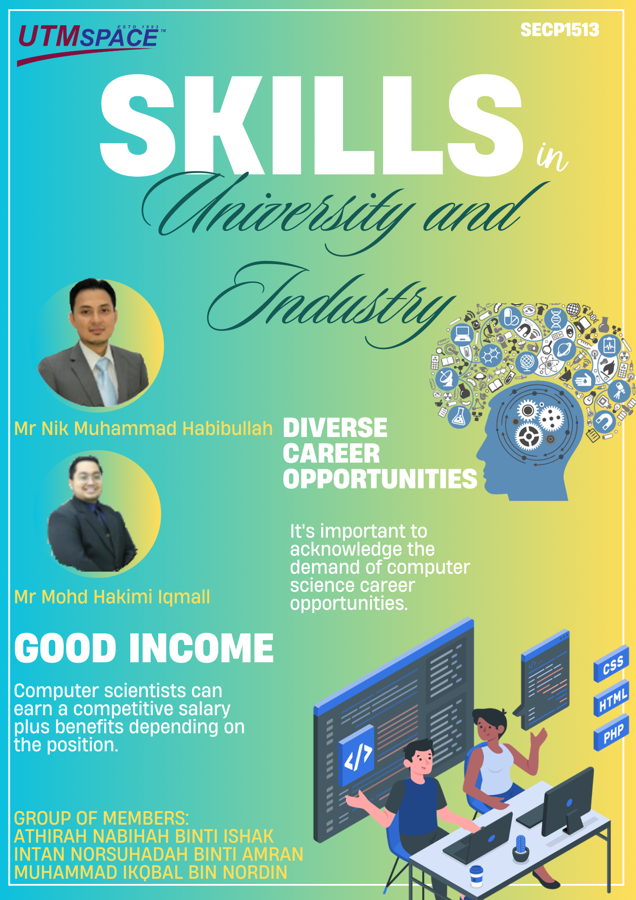

The purpose of this speech was to share insights about the skills needed for success in the tech industry and offer guidance to students preparing for their careers.

1. **Overview of the Talk**

Mr. Mohd Hakimi Iqmall commenced his professional journey as an intern at **ME-Tech Solution**, where he played a significant role in the development of a **ship simulator for TLDM**, with a particular focus on **3D modeling and animation**, thereby establishing a strong foundation in system development. Currently, he holds the position of **Project Manager/System Analyst** at **UTM Digital**, where he is leading the development of the **Sistem Saraan Perkhidmatan Awam (SSPA)**. His career trajectory exemplifies consistent professional advancement and a steadfast commitment to excellence in his field.

He emphasized the significance of two essential competencies: **technical** and **management skills**. His technical expertise includes proficiency in programming languages such as C++, Python, Java, and PHP, advanced skills in system debugging to identify and resolve issues, and a strong awareness of security vulnerabilities, particularly in mitigating threats such as SQL injection. In the domain of management, he demonstrates capabilities in problem-solving, effective communication, risk management, quality assurance, and a comprehensive understanding of Software Development Life Cycle (SDLC) methodologies, including Waterfall, Agile, and DevOps.

He emphasized the importance of staying up-to-date with the latest technologies, particularly highlighting the need for adaptability and expertise in emerging fields such as artificial intelligence (AI) and blockchain. He asserted that acquiring skills and knowledge in these areas is essential for ensuring long-term sustainability and maintaining relevance in the industry over the next 10 to 15 years.

He concluded his speech with an impactful quote and memorable advice that left a lasting impression on the audience. He urged everyone to “**Be brave to challenge yourself** them that *Life begins at the end of your comfort zone*. He also emphasized the importance of continuous growth with the advice to **Never stop learning** quoting, *Live as if you were to die tomorrow. Learn as if you were to live forever."* (Hakimi Iqmall, 2024).

In conclusion, Mr. Mohd Hakimi emphasized that staying updated with the latest technological trends, coupled with the development of strong soft skills, is essential for achieving success in the tech industry.

Next speaker is Mr Nik Habibullah bin Muhammad Nizam. He is entrepreneur that invited to give talk regarding Industrial talk. He graduated from UTM in 2005 with a degree in Management Information System. His experience as a entrepreneur almost 19 years enough to give inspiration student in world IT to become entrepreneur, student need to strong in fundamental and creative with innovative to making something new. Among the experience Mr. Nik Habibullah has been began as a student his get significant project for UTM library selected on the basis of video montage for the launch Aman Malaysia. After graduated before becoming entrepreneur, he is special officer at the Ministry of the Government Malaysia (KPT) under Dato’ Adnan Barber and then working as a RO in UTM for 1 year.

He feels that time his can gain more money if the idea in commercial, so in first step he develops NI Solution Sdn. Bhd to become entrepreneur. His success that can establish Micro Semiconductor Shd. Bhd that before this company belonging his friend. His friend sells Micro semiconductor Sdn. Bhd in cheaper price because of company issue and commitment. He receives company in condition the company not stable and can to establish the company to become success. **Ni Solution Sdn. Bhd** before this enterprise company, to being firm in industries and get tender from Government, NI Solution enterprise change no NI Solution Sdn. Bhd. During Pandemic, Mr. Nik Habibullah has a struggle to get project from the Government, He develop Getme Hired. Not denied He is successful entrepreneur that always provide new idea, even in Pandemic his can success develop Getme Hired that Getme Hired is company to help student provide CV or resume which coincides with carrier student.

He shared in Getme Hired modules before involve carrier student or user first must know yourself, start from knowing our-self, especially strength and career goals. Second is Job Application, learning the preparation to build CV and pro-folio. Third is Job Interview, student or user need to ready for the interview and how to handle rejection. Lastly from the modules his share Job Survival, stay relevant in industry and how to jump for next company. He also develops Dialysis Manager.IO. Dialysis Manager is an integrated system designed specifically to improve the quality of services of hemodialysis system, user that use this product they can access system in anytime and anywhere. After Pandemic, He comeback with project Government, the latest project is the taxation assessment system under DBKL. He shared to become entrepreneur, first must know what is the target. From the target need to know how to generate your idea to achieve the target.

The basic skills required for computer science and skills required by industry must strong in fundamental such as C, C++ and database. Common mistakes in job hunting are your degree should **EMPOWER** you to pursue opportunities, make up some time to **PARTICIPATE** in activities and start as **EARLY** as possible. The competition gets tougher by days. He shared the quote “Don’t limit yourself based on your bachelor’s degree. If want to make change and step into a new field, do whatever it takes to get there. It could be the best turning point in your life.” (Nik Habibullah, 2024).

In conclusion, Tips from Mr. Nik Habibullah, to become entrepreneur we need the contact with relate business. To start network in entrepreneur can be start from university such as engage self in faculty activities and program university to get networking

1. **Reflections**

**MUHAMMAD IKQBAL BIN NORDIN SX240238ECJHS03**

From the talk, I learned the importance of developing both technical and soft skills to succeed in computer science. In the next four years, I will focus on improving my programming skills, gaining hands-on experience through internships, and staying updated with emerging technologies like AI and cloud computing. I aim to contribute to innovative projects and continue learning to remain competitive in the industry.

**ATHIRAH NABIHAH BINTI ISHAK SX240235ECJHS03**

From the talk, I learned that we can start to do job hunting before graduate and do not wait until your graduation day. Computer science majors have a lot of opportunities to network. It’s important for my career growth next 4 years as we start create professional relationships with other students, professors or staff members that require the completion of an internship, which can provide even more professional networking opportunities. Furthermore, we need to define our own success and don’t follow other people’s dreams. It’s always about you and yourself.

**INTAN NORSUHADAH BINTI AMRAN SX240234ECJHS03**

The reflection from the talk is understand computer science apart from working is government and private we can be as entrepreneur. Computer Science is in very high demand in the market right now. After attend this industry talk, in four years I want to develop system and machine start from my problems during working. My company 5DX machine use 2D image that cannot to capture image reject in accuracy. So want to develop system to use system that can capture image in clearly and get the percentage barrier fill for solder cavity.

1. **References**

Mr. Mohd Hakimi Iqmall, (2024 December 17). Designing Success From Graphic Multimedia to Leading Project at Universiti Teknologi Malaysia. <https://utm.webex.com/recordingservice/sites/utm/recording/495193b7b8d1499da9109e304e3f154a/playback>

Mr. Nik Habibullah (2024 December 17). Preparing for Entrepreneurship in IT Essential Skills and Strategies for University Students at Universiti Teknologi Malaysia. <https://utm.webex.com/recordingservice/sites/utm/recording/495193b7b8d1499da9109e304e3f154a/playback>

Indeed, (2024 August 16) Career Guide by Indeed Editorial Team [12 Reasons To Be a Computer Science Major (Plus Jobs) | Indeed.com](https://www.indeed.com/career-advice/finding-a-job/reasons-to-be-computer-science-major)

Elise Deitrick, (**2022 November 1)** Codio's VP of Product & Partnerships <https://www.codio.com/blog/mastery-based-learning-computing-education>